**Question 1 – Introduction of Software and Use Case Diagram**

VLC or VideoLAN Client is an open source and free cross platform media player that can play a wide variety of multimedia files such as video and audio files. VLC was an academic project for streaming video by a non-profit organisation named VideoLAN in the mid-1990s in Paris, France. VLC runs on all popular operating systems and different mobile devices.

In this project we will be focusing on VLC for android which is a port of VLC Media Player for android devices. The VLC app can play almost all types of video formats such as mp4, avi, mkv, mov and audio formats such as ogg, flac, wv and aac files and also Network Streams such as adaptive streaming. VLC also supports disk share through Network Drives and Network Shares similar to the original desktop version on PC. VLC also support Closed Captions, Teletext and Subtitles in their software.

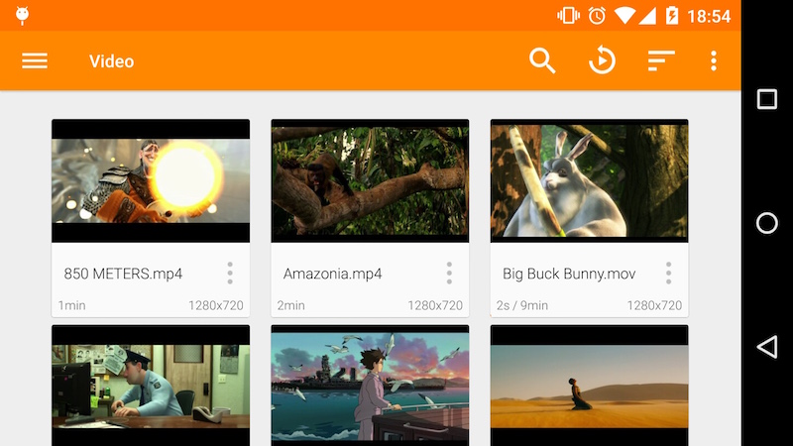

Figure 1. VLC Video Library (Insert citation reference here)

The VLC app has a media Library for both audio and video files, which allows browsing to the phone’s folders directly. It has a complete audio media library that supports headset controls and cover art for each of the songs in the library.

VLC has a wide variety of features which is why we are only focusing on the media library part of the app for this project.

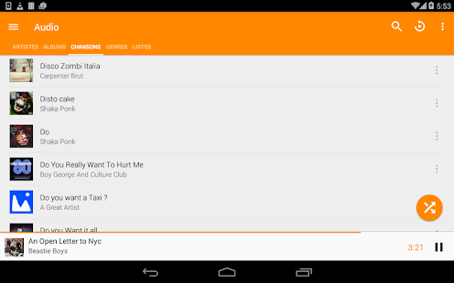

Figure 2. VLC Audio Library (Inset citation reference here)

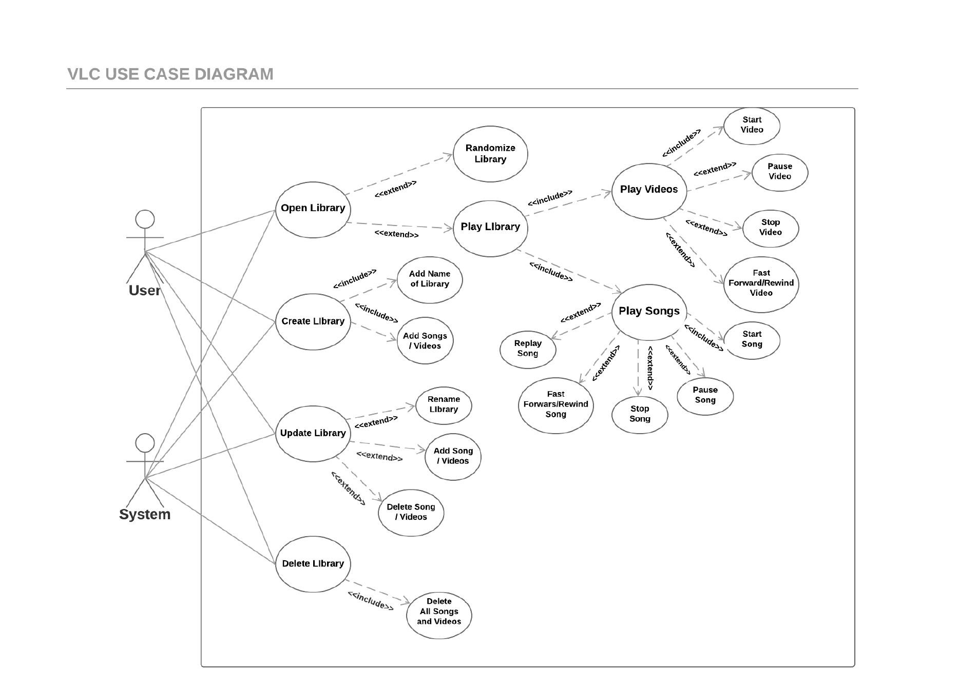**Use Case diagram**

The media library has 4 main function or use in the VLC system. We also have 2 actors in the diagram, they are the User and the System. We have included the system as an actor in the diagram because the media library is just a part of a larger system that the VLC software controls. The 4 main functions that the media Library does are to open, create, update and delete a library. The open library function has 2 extends which are to randomize the songs and videos in the library and to play the video or audio files in the library and whilst playing the files it still has a few more extend functions which are to stop, pause, fast forward/rewind and to replay the song or video. The Create Library has 2 includes which are to add a name of the created library and to add songs and videos in the created library. The update function has 3 extends which are to rename the library, add new song or videos to the library and to delete old songs or videos in the library. Lastly the delete library function has an include that deletes all the files in the library.

**Question 3 – Components and Connectors**

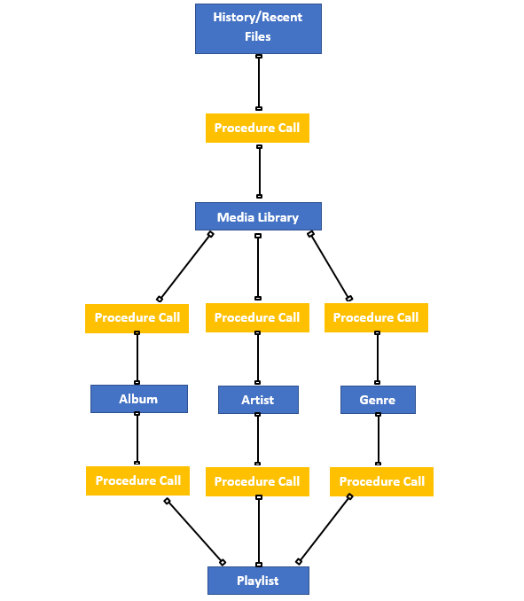

**References:**

**“DON’T FORGET APA REFERENCING”**

**“JUST SET THE REFERENCES AS WEBSITE AND NO AUTHOR OR DATE CAUSE WEBSITE ANYWAY 😉”**

<https://www.videolan.org/vlc/download-android.html>

<https://play.google.com/store/apps/details?id=org.videolan.vlc&hl=en>

**References for photo:**

**“Insert the citation under the photo”**

**VIDEO LIBRARY**

<https://images.videolan.org/vlc/screenshots/android/library-video-landscape-medium.jpg>

**AUDIO LIBRARY**

https://lh3.googleusercontent.com/PES21T6lSyGV3qG-xUGXQjPnrZssxIkquURtY1s8occr6jnoK9RbhKqduDCS-NAHLUg=w720-h310